**Hotel management system**

CH.V.S.VISHNU VARDHAN

GROUP MEMBERS :

|  |  |  |  |
| --- | --- | --- | --- |
| S.NO | NAME | ENROLLMENT NUMBER | SECTION |
| 1 | CH.V.S.VISHNU VARDHAN | U101116FCS026 | S4 |
| 2 | OLETI BHANU PRAKASH | U101116FCS080 | S3 |
| 3 | E.H.V.D.PRASAD | U101116FCS032 | S4 |
| 4 | K.D.S.VIVEK | U101116FCS055 | S4 |
| 5 | NIKHL POTHANA | U101116FCS0 | S4 |

INTRODUCTION:-

The current object of this hotel database management system is to

EXISTING SYSTEM :-

* The current manual system uses registers, paperwork and direct human language communication by mouth to manage the hotel and its system which delays information transmission.
* In this system availability of vacant room status is to checked manually through the registers.
* Registers may be prone to unauthorized modification due to low data security levels and standards. Due to this, guest data is not secure.
* The accounts department generates the bills on daily basis and delivered to the guests in their rooms at dusk by the service maids.
* Data in the registers may prone to errors which leads to inconsistency and redundancy of data.

New SYSTEM:-

* The new system is computer organized system which Enforce security measures to avoid unauthorized access to guest records.
* Maintenance of data becomes very compatible and easy than Existing System.
* Guests and employee can fetch data comfortably like booking of rooms, ordering of food, maintaining of transport, etc.
* Generation of receipts and bills can be done for all deeds at an instant during checkouts.

ENTITIES AND ATTRIBUTES:-

Customer(Cust_Id, Cust_Name, Address, email, Gender, Ph_No)

Room(Room_Id, Type, Room_No)

Transport(Transp_Id,Address)

Food(Rcpt_No,Food_Id,F_Qty,D_Qty)

Laundry(Laundry_Id,No_Of_Pieces)

Sports(Sport_Id,Start_Time,End_time)

Department(Dept_Id,Dept_Name)

Employee(Emp_Id,EF_Name,EL_Name,Emp_Address,Ph_No,Emp_Email)

Invoice(Invoice_Id,Particulars)

ER DIAGRAM:-

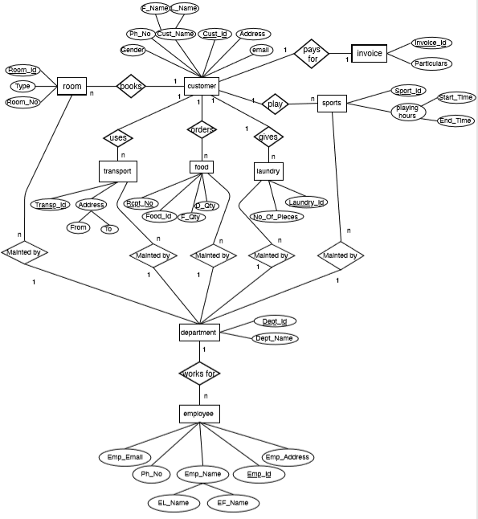

MYSQLTABLES:-

CUSTOMER TABLE:

CREATE TABLE IF NOT EXISTS `hdbms`.`Customer_Table` (`RegNo` INT, `Cust_Id` DOUBLE, `FName` VARCHAR(45), `LName` VARCHAR(45), `Gender` ENUM('M', 'F', 'O'), `Contact_No` DOUBLE, `Email` VARCHAR(70) , `Address` VARCHAR(150), PRIMARY KEY (`Cust_Id`))

|  |  |  |
| --- | --- | --- |
| ATTRIBUTES | TYPE | KEY |
| RegNo | INT | Primary |
| Cust_Id | DOUBLE |  |
| FName | VARCHAR(45) |  |
| LName | VARCHAR(45) |  |
| Gender | ENUM('M', 'F', 'O') |  |
| Contact_No | DOUBLE |  |
| Email | VARCHAR(70) |  |
| Address | VARCHAR(150) |  |

Employee TABLE

CREATE TABLE IF NOT EXISTS `hdbms`.`Employee_Table` (`Staff_RegNo ` INT, `ICard_No` VARCHAR(45), `Staff_FName` VARCHAR(45), `Staff_LName` VARCHAR(45), `Address` VARCHAR(250), `Email_Id` VARCHAR(50), `Phone_No` DOUBLE, `Salary` FLOAT, `Department_Dept_Id` INT, PRIMARY KEY (`ICard_No`, `Department_Dept_Id`), INDEX `fk_Employee_Table_Department1_idx` (`Department_Dept_Id` ASC), CONSTRAINT `fk_Employee_Table_Department1` FOREIGN KEY (`Department_Dept_Id`) REFERENCES `hdbms`.`Department` (`Dept_Id`)

|  |  |  |
| --- | --- | --- |
| ATTRIBUTES | TYPE | KEY |
| Staff_RegNo | INT |  |
| ICard_No | VARCHAR(45) | Primary |
| Staff_FName | VARCHAR(45) |  |
| Staff_LName | VARCHAR(45) |  |
| Address | VARCHAR(250 |  |
| Email_Id | VARCHAR(50 |  |
| Phone_No | DOUBLE |  |
| Salary | FLOAT |  |
| Department_Dept_Id | INT | Foreign |
|  |  |  |

DEPARTMENT TABLE

CREATE TABLE IF NOT EXISTS `hdbms`.`Department` ( `Dept_Id` INT, `Dept_Name` VARCHAR(45), PRIMARY KEY (`Dept_Id`))

|  |  |  |
| --- | --- | --- |
| ATTRIBUTES | TYPE | TYPE |
| Dept_Id | INT | PRIMARY |
| Dept_Name | VARCHAR(45) |  |